
DATA ANALYTICS ASSIGNMENT (ITNPBD6)


Submitted to Submitted by
Kevin Swingler Vinod Kumar Sudan
2538186

INTRODUCTION: -

In the past decade, it was often seen that the major challenges that banks had was its huge debts example RBS’s bad lending and other poor trading decisions (Treanor, 2018), and rightly so as there were no set rules for authorizing / sanctioning the debts. Nobody knows to whom the debts should be sanctioned or not. Even if the debt is sanctioned, nobody could predict whether the person will pay back the debt or not. However, in today’s time we can predict the outcome and we can decide as to whom the debts should be sanctioned or not with the help of the Machine Learning Techniques and that’s exactly the task in our hands.

To predict whether the person will pay back the debt or not we have been provided with the past bank’s data which contains the customer details as to whom the debt was sanctioned, how much was sanctioned (Current debt), there Age, how many years they have been staying at the present address, what is there employment status, how much do they earn i.e. Income, do they own a house or they live in a rented accommodation, most importantly their count for CCJ’s (County Court Judgment), which explains as to how many times they had been a defaulter in repaying the debt and finally the outcome, whether they have paid the debt or not.
The terminology that I will be using in the report are “Task” and “Model”. The task defines the duty, job, or a piece of work to be done and the Model defines the process through which the work can be done, and the desired result or outcome can be achieved. Therefore, in this report the ‘Task’ will refer to the work to be done and the ‘Model’ will refer to the process being followed.

The project methodology that I will be using in this project is CRISP-DM i.e. Cross Industry Standard Process for Data Mining, which can be explained with the following 6 major steps: -
- Business Understanding: -

In this step the primary focus is on understanding the objectives and the requirements of the project from the business perspective and then applying that understanding into data mining problem definition and a preliminary plan.

- Data Understanding: -

First the data is collected in this stage and then an attempt is made to understand the data i.e. to identify the quality of the data, to uncover the first insights into the data and determine interesting subsets from the data to form notion for hidden information.

- Data Preparation: -

This stage comprises of formulating the data to construct a final data set from the initial raw data i.e. considering incomplete data, noise in the data, inconsistency of data which indeed a part of data cleaning. Also performing data reduction if necessary i.e. reducing the quantity of data but producing the similar or better analytical results.

- Modelling: -

This stage involves the selection and application of the modelling techniques like “Decision Tree” and “Multilayer Perceptron (MLP)” etc. However, the modelling technique like the “Neural Network” has some furthermore requirements regarding the form of data, therefore there is a loop back here to data preparation.

- Evaluation: -

Once the models have been built that appears to have high accuracy or quality. It needs to be evaluated to ensure that they generalize against unrevealed data and sufficiently considering all the key business issues. Then selecting the most appropriate model.

- Deployment: -

This stage comprises of the deployment of the most appropriate model in a coded form into an operating system to perform best and categorize on unrevealed data as it arises. Also, the coded description must also incorporate the stages from Data Preparation to Modelling, so that the model should treat new raw data in the same manner as it did earlier.

Data Summary: -

- List of Variables: -
- Customer ID- The customer ID is numeric in nature and is discrete variable as there can potentially be infinite number of customer ID’s but distinct. It doesn’t give any insight whether the customer will repay the loan or not. Also, removing the customer ID attribute doesn’t impact the result i.e. accuracy of the model. Most importantly the “Attribute selection” method with the help of “Info Gain Ranking Filter” in ‘Weka’ has also ranked customer ID towards last. Hence will not be considered for building the model.
- Fictional Surname- It is nominal in nature and is discrete as well, as it cannot be quantified, no arithmetic operations can be performed on them and in turn there is no defined order for their occurrence. Similar to the customer ID variable, this variable doesn’t have any impact on the model accuracy. However, the attribute selection method has ranked it with high importance. Therefore, in this case I have taken a decision by not considered this variable for building the model as this variable doesn’t give any insight whether the customer will repay the loan or not.
- Age- It is numeric in nature and is continuous. The values in this variable are whole numbers which can be quantified and in turn defines it to be discrete. However, the concept of age is always continuous. Therefore, it is continuous in this case as well. Also, the arithmetic operations can be performed on them which makes it to be numeric too. Most importantly, this variable doesn’t have any impact on the models’ accuracy and the attribute selection method has ranked it towards last with no corresponding value. Hence, it will not be considered for building the model.
- Gender- It is nominal in nature and is discrete(Categorical) as it cannot be quantified but can be categorized as either male or female. Gender as a variable doesn’t give any insight whether the customer will repay the loan or not. Even if the attribute selection method has selected the gender attribute, I have not considered it for building the model based on the fact that when I removed the variable and build the model again there was no change i.e. it didn’t impact the accuracy.
- Years at Address- This variable is numeric and discrete as arithmetic operations can be performed on them and it has whole number as a value which makes it to be discrete as well. The attribute selection method has ranked this variable towards last for building the model with no corresponding value. Therefore, I have also decided by not considering it to build the model.
- Employment status- It is nominal and discrete(Categorical) as it cannot be quantified but can be categorized as Employed, Unemployed, Self-employed, and Retired. On this variable no arithmetic operations can be performed. However, the attribute selection method has considered this variable to build the model and so did I, as this is the most important variable which can give insights whether the customer will repay the loan or not.
- Country- Nominal and discrete(Categorical) as it cannot be quantified but can be categorized with the countries names. The attribute selection method has selected this variable to build the model but with very low average score and merit value. However, I have taken decision just opposite to the attribute selection method i.e. by not considering this variable to build the model as country doesn’t give any insight about the decision algorithm need to make i.e. whether the customer will repay the loan or not. Most importantly this variable doesn’t impact the models’ accuracy when it was not considered.
- Current Debt- This variable is Numeric and continuous as arithmetic operations can be performed on it and also it continuous based on the fact that I can get various insights from its mean and standard deviation which I can get if I will consider it as continuous and not discrete. The attribute selection method has selected this variable for building the model and so did I. Also, this variable negatively impacts the accuracy when it was not considered to build the model.
- Postcode- It is Nominal and discrete as no calculation can be performed on it and since it has all distinct value therefore, it is discrete. The attribute selection method and “cfs subset eval” method with ranker and greedy stepwise search method respectively has considered it for building the model, however, I have decided just opposite to it as it has too many distinct values which doesn’t give any insight, and which cannot help in predicting whether the customer will repay the loan or not. Hence, I have decided not to consider this for building the model.
- Income- This variable is one of the most important to build the model. It is Numeric and continuous as the arithmetic operations can be performed on them and can come up with valuable insights that can help in predicting whether the customer will repay the loan or not. It can be discrete based on the fact that there are too many distinct value which is difficult to display for analysis. However, if I treat it as continuous then it becomes easier and gives valuable insights for example - within which income range more customers have repaid the loan. Therefore, I have considered this variable as continuous. Moreover, the attribute selection method has not considered this variable for building the model. However, I have decided to consider it
- Own Home- This variable is Nominal and Discrete(Categorical) as no arithmetic operations can be performed on it and can be categorised as Rent, Own, and Mortgage. Own home as a variable have been considered by the attribute selection method to build the model and so did I, as this variable gives me the insight about the customer liabilities and which can help in making a prediction i.e. whether or not customer will repay the loan or not.
- CCJ’s- This is one of the most important variable to build the model as this form the basis for what I have to predict. It is Numeric and Discrete as it comprises of numeric values on which arithmetic operations can be performed. It is discrete based on the fact it has all whole number as a value and less number of distinct values and with less number of distinct values, it becomes more insightful to predict whether the customer will repay the loan or not. Also, the attribute selection method has considered this variable with the highest average and merit scores in order to build the model and so did I.
- Loan Amount- This variable is Numeric and Continuous similar to the income variable as an arithmetic operation can be performed on it and continuous because it will be easier to find the correlation and will be easier to analyse visually. This variable was not considered by the attribute selection method with no corresponding value. However, I have decided just the opposite to it as after considering all the liabilities, assets, now it’s the time to consider the loan amount after which the algorithm will be able to get an insight i.e. whether the customer will be in a position to repay the loan or not.
- Outcome- This variable is Nominal and Discrete(Categorical) as no arithmetic operation can be performed on it but can be categorised as Paid or defaulted. This variable is used just to display the predicted result as per the task and the valuable insights it has from other variables. Therefore, this variable is definitely present in every model.

DATA PREPARATION: -

Data preparation is one of the most important stage in the data analytics project. In this stage the data is properly understood and is critically examined if there is any discrepancy in the data or not. If there is a discrepancy then the question arises- what kind of discrepancy, whether or not that discrepancy be sorted, whether it is better to get rid of that row which has discrepancy or is it better to rectify it. After finding answers to all such question we can say that the data is prepared. In this project, I have found few discrepancies in the data specially in attributes like- “Years at address”, “Income”, “Gender” and “CCJ’s”. According to me those were the typing errors. Hence, I have corrected it by the following ways through python programming i.e. “In years at address”, I found the anomalies as 560, 410, 300, and 250 years. Which appears to me as if there is one extra digit mistakenly typed and there were no more anomalies in this variable. Therefore, I have deleted the last digit from all these values i.e. “Zero”.
Similarly, in “Income variable” I found values like 1,80,000 and 2,20,000 wherein all other values were not even close to it as in they lie between 7500 to 54,500. Therefore, I have deleted the last digit and brought those anomalies to the same range as others as it again appears to be the typing error.

In “CCJ variable” I found discrepancies in values like 100 and 10 wherein all other values were falls under 0 to 3. Therefore, these discrepancies also appear as typing error with two or one extra zeros. Hence, I have deleted the zeros and brought them to the same range.

In “Gender variable”, I found discrepancies in values. However, I have not considered this variable to build the model. Therefore, I have not done data preparation on this.

INCOME VARIABLE BEFORE DATA PREPARATION: -
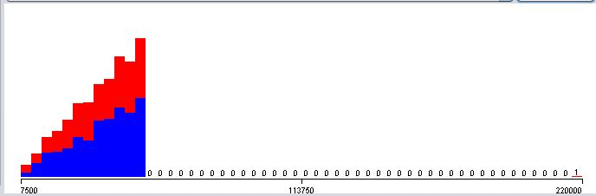

INCOME VARIABLE AFTER DATA PREPARATION: -
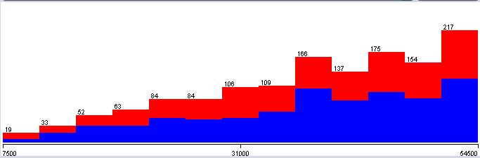

MODELLING: -

- DIFFERENT METHODS USED: -

With an aim to achieve the best result with respect to the task in hand, I have used various methods which is as follows: -

- SPLITING THE DATA: -
In this, I have divided the data in 70:30 ratio, where 70% is for the training and validation and rest 30% is for the test. In this data I have 2000 instances which I have manually divided in to two parts i.e. 1400 and 600 which corresponds to 70% and 30% respectively.
- ATTRIBUTE SELECTION: -
This method is for attributes selection. In this method I have used “J48” and “Multilayer Perceptron” as a classifier, “InfogainAttributeEval” as an evaluator, and “Ranker” in search tab. The ranker will rank the attributes in descending order with the help of its corresponding average and merit value. The corresponding value shows how important that attribute is as per the attribute selection method.
- C V PARAMETRE SELECTION: -
This method is used for the hyperparameter selection where I can explicitly define the range of the CV Parameters and can also specify the classifier as in for which classifier I want this method to run such as J48 or Multilayer Perceptron(MLP) with the defined range of CV Parameters. Hence, I have used this method for both these classifiers. For “J48” I have defined the confidence factor referred as ‘C’ from 0.1 to 0.9 with 9 iterations and the minNumObj referred as ‘M’ from 1.0 to 10.0 with 10 iterations. Wherein, for Multilayer Perceptron (MLP) I have defined the range for the number of nodes in the hidden layer referred as ‘H’ from 2 to 20 with 5 iterations and the learning rate referred as ‘L’ from 0.1 to 0.5 with 5 iterations. The range specified for ‘H’ will give as to how many nodes in a layer will turns out to be a best combination with the learning rate which was achieved from a range specified. However, to add the number of hidden layer, I have manually gone to the MLP settings and incorporated the number of hidden layer with the value of ‘H’ which yields the best result.

- TECHNICAL DESCRIPTION OF DECISION TREE: -
Decision tree is one of the most important and commonly used machine learning techniques which is a type of supervised machine learning technique as well. In this we explain the input and its corresponding output in the training set, where the data is divided, and the decision are made based on certain parameters. Most importantly as the name signifies, it has a tree structure to make decisions with two entities such as “Decision node” and “Leaves”, where leaves are the outcomes after the decision is made and the decision is taken at the decision node.
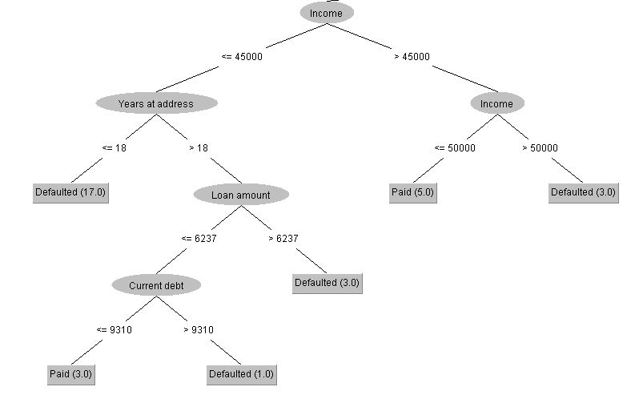

Fig: A Part of the actual “Decision Tree”.

The decision tree can be explained with the above figure that shows a part of an actual decision tree which I got after building the model. However, the actual decision tree that I got has a lot more of decision nodes and leaves which makes it difficult to display in the report. Wherein to explain the functionality of the decision tree a portion of it can be used and that’s exactly what I have done here.
As we can see that the above figure starts with a decision node “Income” which has a certain parameter associated to it i.e. the value of income <= 45000 or > 45000, which helped that node to decide and lead to further decision node i.e. ‘Years at address’ on one side and ‘Income’ on another. In decision tree this process continues until they reach to a leaf node i.e. an outcome or often called as ‘Class Labels’, which is displayed in a rectangle box.
Also, Decision tree can be categorised as two types such as “Classification Tree” and “Regression Tree” and I have used classification tree in this project where an outcome is either ‘Paid’ or ‘Defaulted’.

In decision tree there are a set of hyperparameter which are really important, and which can impact the outcome of the model. Those hyperparameter are ‘Confidence Factor’ and ‘Minimum Num Objects (minNumObj)’ whose parameters are modified to measure its effectiveness of post-pruning. Also, pruning is a technique which reduces the size of decision tree by removing the sections that provides less information to classify the instances for example:

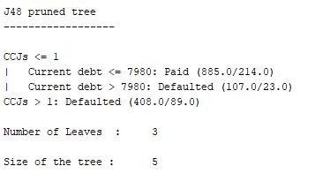

- TECHNICAL DESCRIPTION OF MULTILAYER PERCEPTRON (MLP): -
The Multilayer Perceptron is a part of a supervised learning technique i.e. back propagation and a feed forward neural network which is divided in to ‘n number’ of layers of nodes, where the first layer is often called as Input layer. The input layer inputs the variables to the next hidden layer which consists of number of neurons. The output from the calculations performed on those neurons are then transmitted with the help of an ‘Activation function’ as a single value. Then those single values become an input for the next hidden layer and this process continues until it reaches an output later which has a class label i.e. ‘Paid’ or ‘Defaulted’.

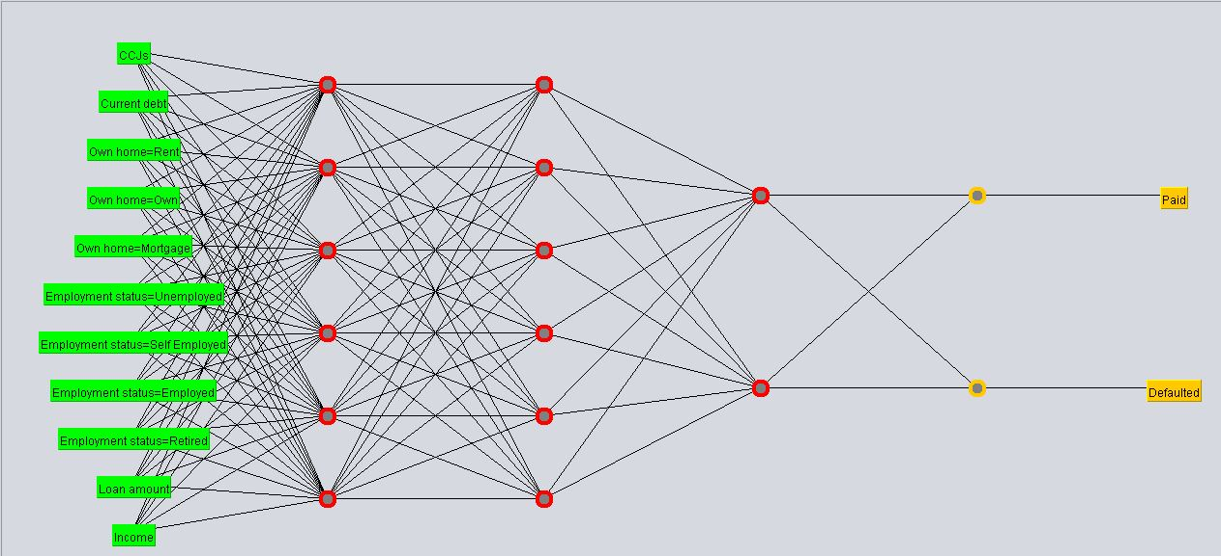

The above figure represents the process of Multilayer Perceptron with an input layer i.e. first layer from the left and the output of that layer becomes an input for the next hidden layer consisting number of neurons and so on. However, at last there is an output layer with two neurons that signifies the class label i.e. either ‘Paid’ or ‘Defaulted’.
Most importantly, there are few hyperparameter variables in MLP whose parameters if altered can impact the model accuracy. Those hyperparameters are ‘Hidden Layers’ and ‘Learning Rate’. In Weka the neurons in a hidden layer is denoted as ‘H’ and the learning rate as ‘L’ which are used while auto tuning the hyperparameter for a better model accuracy or outcome. The learning rate can be altered from range 0.1 to 0.9 and the hidden layer starts with a default value as 2 and can go up to ‘n numbers’ as manually initialised in the MLP settings. In this project I have specified a range for the number of neurons in a hidden layer from 2 to 20 with 10 iterations and learning rate from 0.1 to 0.9 with 10 iterations. Later the CV Parameter Selection method has given me of 6.5 as number of neurons in a hidden layer with 0.4 learning rate as a best optimum combination that yields the best result out of the range specified.

IMPACT ON RESULT BEFORE AND AFTER THE HYPERPARAMETRE WAS VARIED: -

Fig:1
The fig1 shows the multilayer perceptron parameters that model random initialise itself where ‘L’ is learning rate, ‘M’ is momentum, ‘N’ is number of iterations or epoch rate and ‘H’ is the number of neurons in a hidden layer.

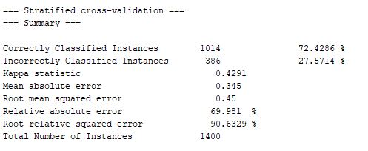

Fig:2

The fig2 shows the impact on the model outcome with the random multilayer perceptron parameters. It shows the accuracy of the correctly classified instances as 72.4286% and for the incorrectly classified instances as 27.5714%.

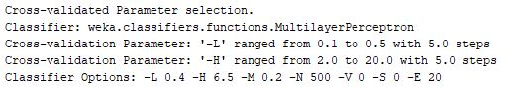

Fig:3

In fig3 the classifier option shows the optimum combination of hyperparameter for Multilayer Perceptron where ‘H’ denotes the number of neurons in a hidden layer and ‘L’ denotes the Learning Rate. This optimum combination of hyperparameter is achieved from the range specified in cross validation parameter i.e. from 2 to 20 with 10 steps and later manually adding the hidden layer in MLP settings with the optimum value that I have from ‘H’.
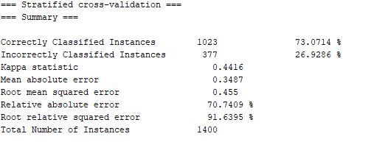

Fig:4

The fig4 shows the impact, the hyperparameter has on the training model after it has been altered as per the fig3 with three extra hidden layers with 6,6 and 2 neurons respectively which was manually defined. The result is for the training data which has 70% of instances i.e. 1400 instances out of 100%. Out of those 1400 instances the change in the hyperparameter of the MLP model has given 1023 as corrected classified instances and 377 as Incorrectly classified instances with 73.0714% accuracy for correctly classified instances and that shows how the model is performing over training data.

SPLITING THE DATA: -
Initially In this, I have divided the data in 70:30 ratio, where 70% is for the training and validation and rest 30% is for the test. In this data I have 2000 instances which I have manually divided in to two parts i.e. 1400 and 600 which corresponds to 70% and 30% respectively. Once the data is divided in a specified ratio. I have supplied that data set to ‘Weka’ where on the basis of the ‘Attribute Selection’ method, ‘cfs subset eval’ method and my understanding i.e. how do I want to use a particular variable in this project, I have deleted the variables which were not considered for building the model. Then the considered variables were then saved as “. arff format” file both for training and test data set so that both the files remain compatible with each other i.e. the number of variables in training data set equals the number of variables in test along with their sequence in which they appear in each of them. Those “. arff format” files were then supplied to weka to build a suitable model.
Result with respect to Percentage split for the training and validation data set for Decision tree (J48) as follows: -
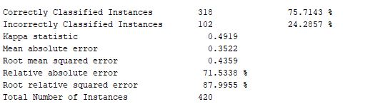

Fig:5
Result with respect to Cross Validation for the training and validation data set for Decision tree (J48) as follows: -
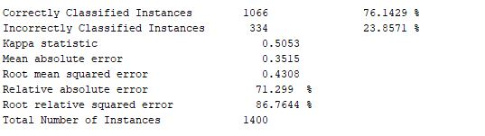

Fig:6
Result with respect to Percentage split for the training and validation data set for MLP as follows: -
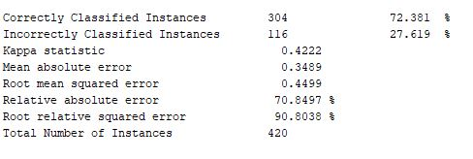

Fig:7

Result with respect to Cross Validation for the training and validation data set for MLP as follows: -
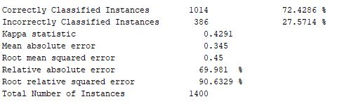

Fig:8

Since, the cross-validation method has yielded the better result in comparison to the percentage split method with respect both the machine learning techniques. Therefore, I have used cross validation for training and validation in this project.
Also, from fig 6 and fig 8 which shows the results the model has achieved through cross validation. The conclusion can be drawn from this as Decision tree with accuracy of 76.1429% has performed better then the Multilayer perceptron with an accuracy of 72.4286%. Therefore, I have chosen Decision tree model, over which I will run the “Test Data” to find how well my model has performed.
ROBUSTNESS OF THE MODEL: -
The robustness of the Decision Tree model can be verified with the accuracy of the “Cross Validation” compared with the accuracy that the same model has achieved in just using the “Training Set” in weka i.e. top left option just above the supplied test set.
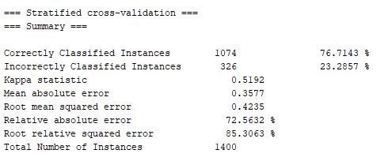

Fig:9
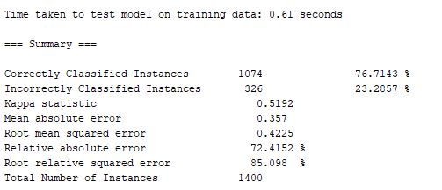

Fig:10

Since the accuracy in fig 9 (Cross Validation) and fig 10 (Training Set) are same. Hence, it verifies the robustness of the model.

RESULTS & ERRORS: -
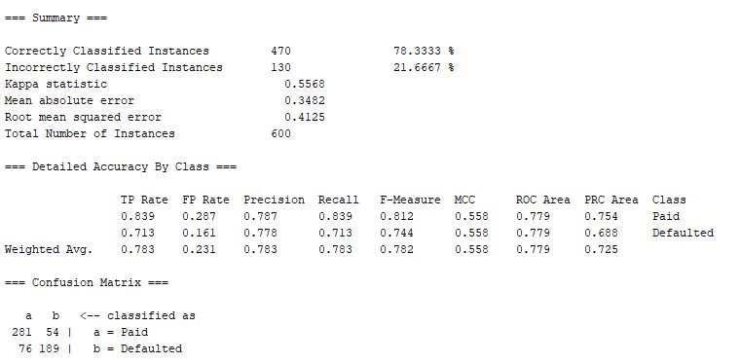

Fig:11

Fig 11 shows how my decision tree model has performed over test data with various terms associated with it, which is explained as follows: -

- Kappa Statistic: -
The Kappa Statistic is a measure to compare the observed accuracy with an expected accuracy. In this it is not only the individual classifiers which are evaluated, however, the classifiers among themselves are also evaluated. The formula for calculating the kappa statistic is as follows:

(Observed Accuracy – Expected Accuracy)/ 1- Expected Accuracy

Where observed accuracy refers the number of instances which were classified correctly throughout the confusion matrix, divided by the total number of instances i.e.

Observed Accuracy = (281 + 189)/ 600= 0.7833
Expected accuracy refers to the number of instances of each class multiplied by the number of instances that the classifier has agreed upon, divided by total number of instances (Need to repeat this for both classifiers) i.e.

Expected Accuracy for paid classifier= (357* 335)/600 = 199.325

Expected Accuracy for default classifier= (243* 265)/600 = 107.325

Total Expected Accuracy = (199.325 + 107.325)/600 = 0.5110

Therefore, now by substituting the values the kappa statistic value can be found as follows:

Kappa Statistic = (0.7833 – 0.5110)/1- 0.5110 = 0.5568

- Mean Absolute Error: -
Mean absolute error states that how closely the model has predicted with respect to the actual outcome. It defines as the centre point for both the prediction and the actual outcome.

- Root Mean Squared Error: -
Root mean squared error can be defined as the sum, of the squares of the difference between the predicted outcome with an actual outcome divided by the total number of data points. Most importantly this process is repeated over all the data points.

- True Positive Rate (TP Rate): -
True positive rate is the measure to find the positives that were correctly classified. For example:
(281/ (281+54)) = 0.839
The above example is for paid classifier and it can be done the same way for the defaulted classifier as well.

- False Positive Rate (FP Rate): -
False positive is a measure to find the instances which were wrongly classified as paid (paid being the positive class) with respect to where it was predicted to be defaulted i.e.
(76/ (76+189)) = 0.287

The above example is for paid classifier which were wrongly classified as defaulted.

- Receiver Operating Characteristic Curve (ROC): -
The ROC curve is a measure of relationship between the two-possible variable at one time, which are inclined to predict the actual outcome.

For Paid: -
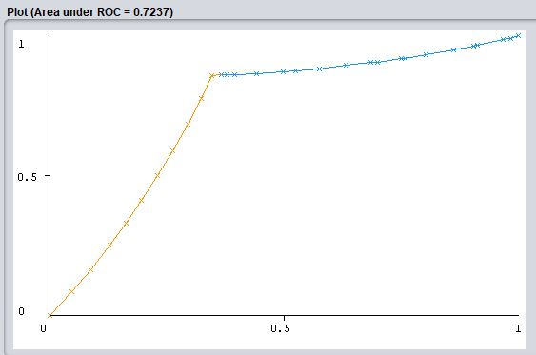

Since, above ROC curve is two dimensional, therefore, in this case the X-axis shows the “False Positive Rate” i.e. when model predicted the outcome to be defaulted however, it didn’t turn out to be, and Y-axis shows the “True Positive Rate” i.e. when model predicted the outcome as paid and it was rightly so and this is possible for every possible classification thresholds. Also, the orange line in the graph represents the true positive rate and the blue line represents the false positive rate. The degree of performance for this curve can be measured based on the fact that how quickly the orange line climbs up, as “Paid” being the positive class and that’s exactly what orange line represents. Most importantly the AUC or the area under the ROC curve is the representation of the percentage out of the total area that belongs to the plot. The AUC also shows more probability for the model predicting the true positive i.e. “More customers will repay the loan” in comparison to the less customers will make a default in repayment.

REFERENCES: -

Treanor, J. (2018). Losses of £58bn since the 2008 bailout – how did RBS get here?. [online] the Guardian. Available at: https://www.theguardian.com/business/2017/feb/24/90bn-in-bills-since-2008-how-did-rbs-get-here-financial-crisis- [Accessed 20 Mar. 2018].

